The Rainbow Chart of Earth System Science Bigger Ideas and Overarching Questions
Don Duggan-Haas, PRI & its Museum of the Earth
dad55@cornell.edu

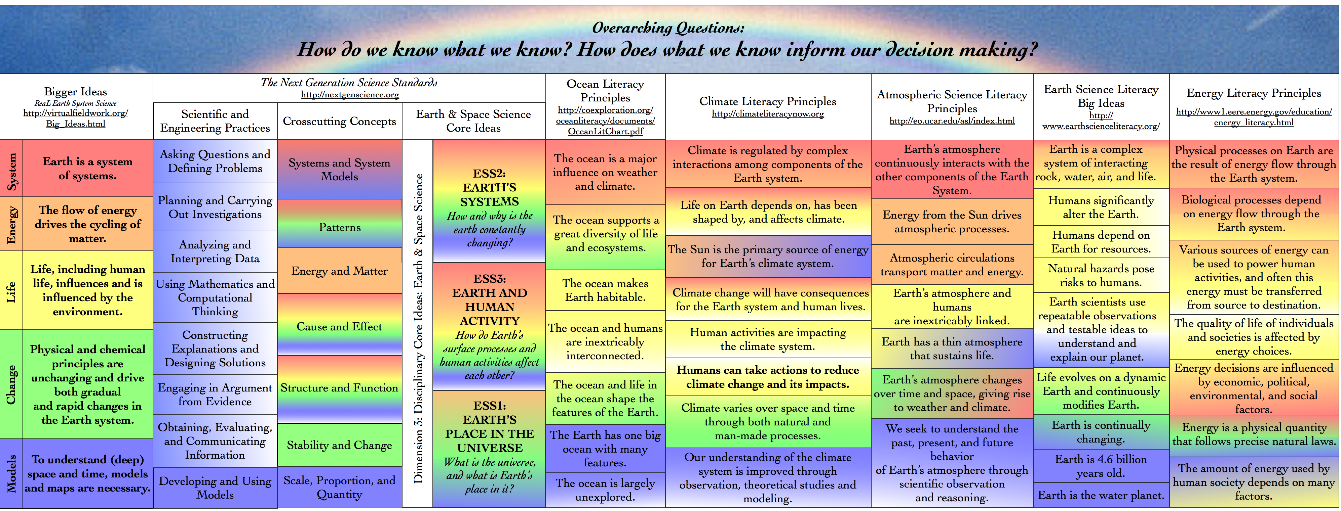

A coherent conceptual framework
The Essential Principles and Big Ideas from the literacy principles documents represent important consensuses about the most important ideas within each discipline, but also represent a challenge to educators. Collectively, they include 38 ideas and 247 concepts, all at the commencement level. There are no examples of creating sets of ideas everyone should understand about any topic that has led to broad understanding the target content, in spite of countless attempts to do just that throughout history. Without a coherent framework to connect them one to another, it isn’t likely that learners will understand or remember them. This “Rainbow Chart” is intended to illustrate those connections.
What do the colors mean?
Each bigger idea has a unique color, and the overarching questions tie this rainbow of colors together and appear white when ideas or principles from the other idea sets reflect the nature of science that is inherent in those questions. Each set of literacy principles addresses all Bigger Ideas and the overarching questions.

What makes ideas bigger?
A bigger idea has the following characteristics:
- The idea cuts across the Earth science curriculum.
- Understanding of the idea is attainable by students and the understanding holds promise for retention.
- The idea is essential to understanding a variety of topics.
- The idea requires uncoverage; has a bottomless quality.
Furthermore, the entire Earth science curriculum is represented by this (small) set of ideas.

Bottomless ideas stated at multiple depths
Here the Bigger Ideas are stated at different depths – a “nickname” of a single word, at the sentence level, and in a short paragraph. We have described each idea in more detail in our series of regionally focused The Teacher Friendly Guides to Geoscience, (see: http://teacherfriendlyguide.org). Of course, many books have been written about each idea, and entire scientific careers may be based upon any one of them and the interplay amongst them.
Stating them as a single word in the form of an idea’s nickname is intended to reduce the demands on working memory. This matters, as Daniel Kahneman notes, “because anything that occupies your working memory reduces your ability to think.”¹

How might I use Bigger Ideas in Instruction?
A simple idea is to have learners describe how a particular activity demonstrates (or is otherwise connected to) one or more of the Bigger Ideas, and to draw connections between ideas and the topic or field site under study.

Explore Bigger Ideas further at:
http://virtualfieldwork.org/Big_Ideas.html.

¹ Thinking, Fast and Slow (p. 30). Macmillan. Kindle Edition
