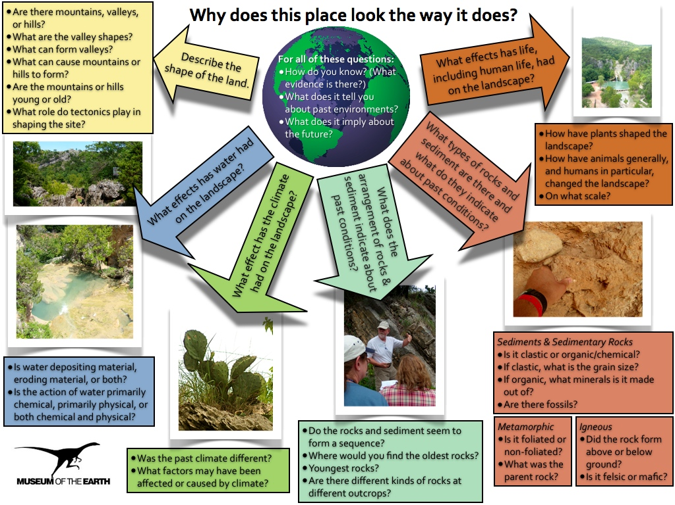
Creating Virtual Fieldwork Experiences as Professional Development |  | 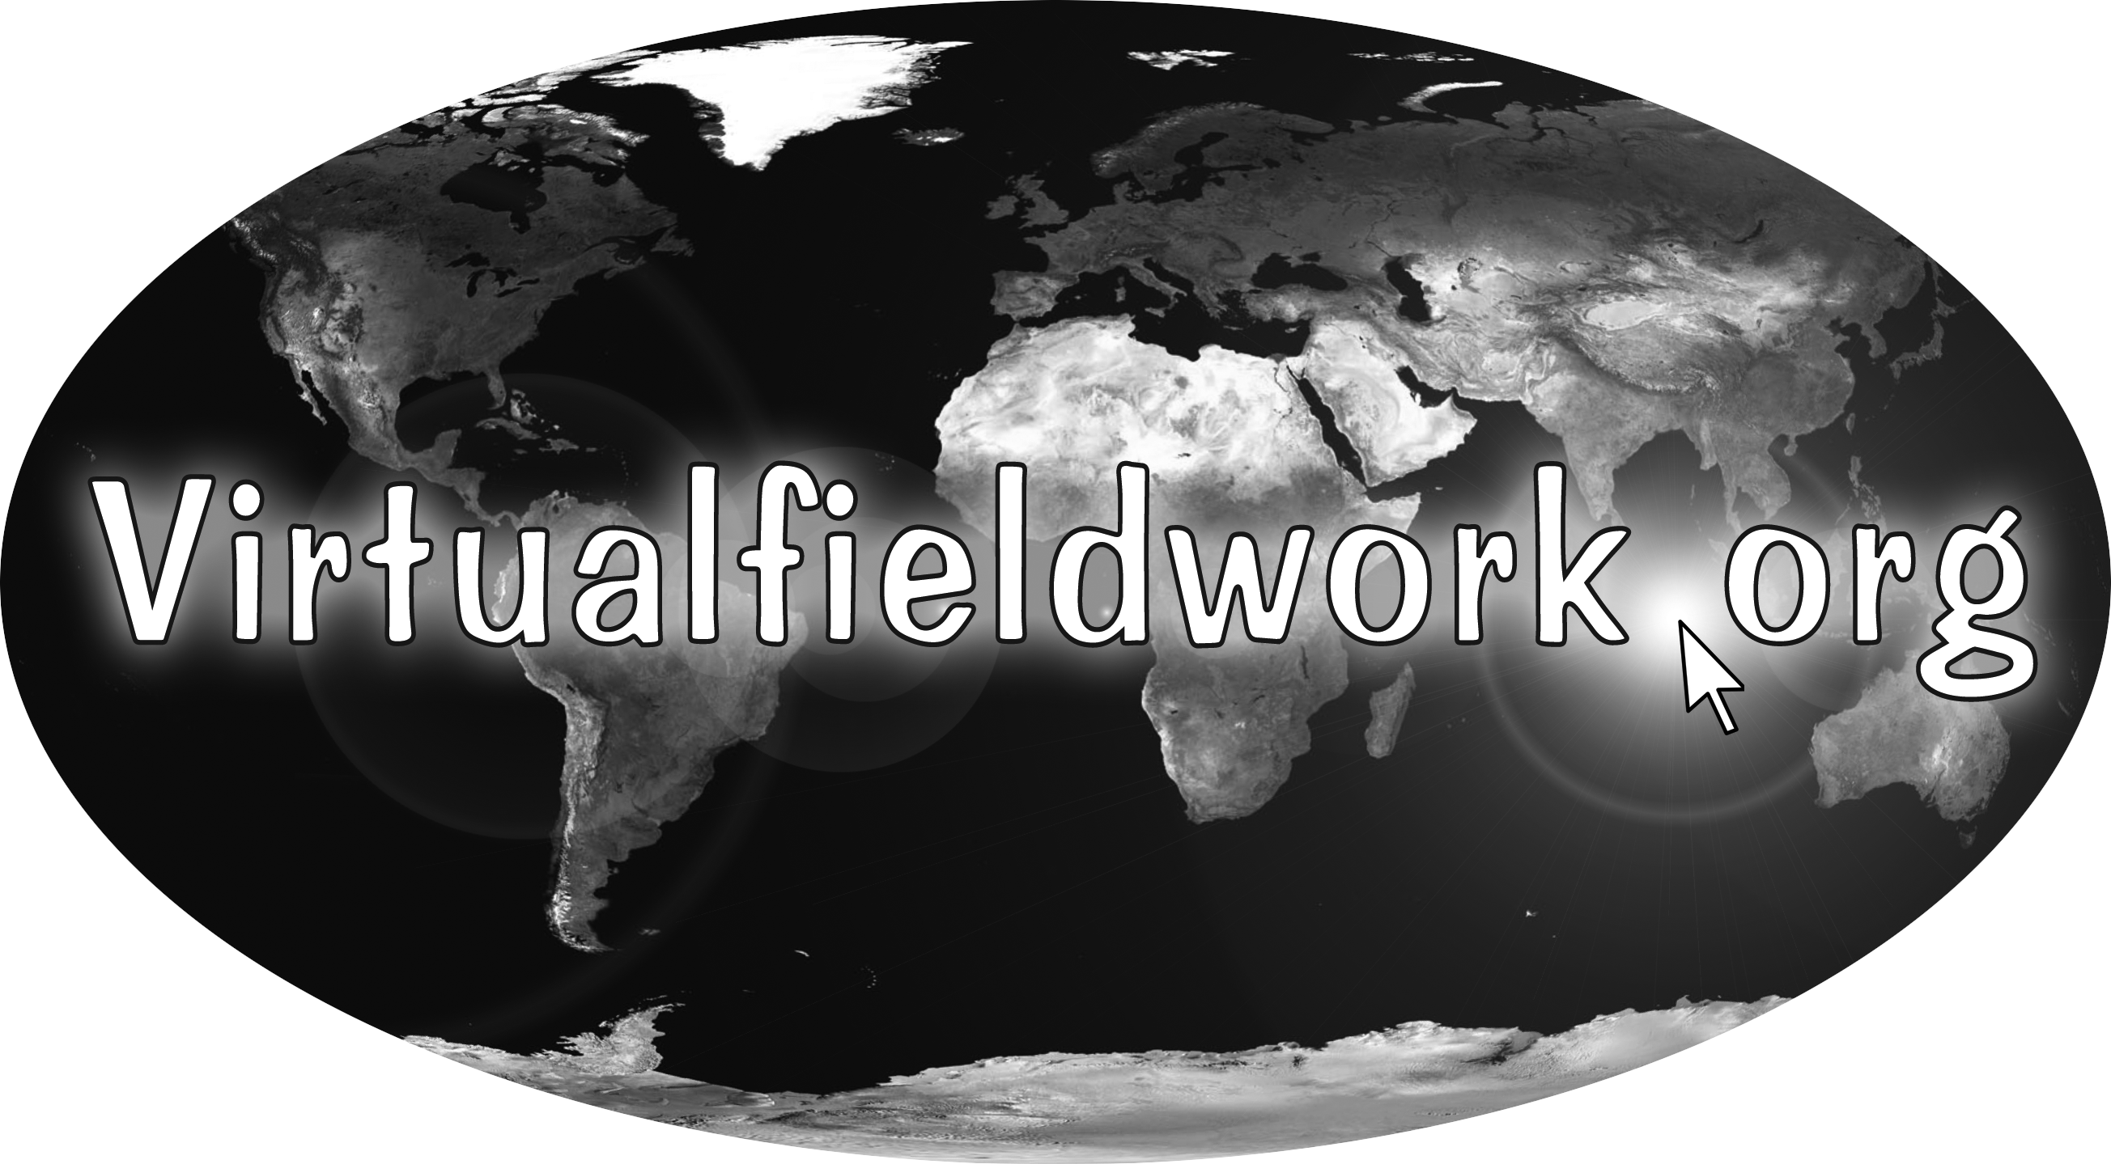

How can we support teachers in the teaching of local and regional Earth system science in an inquiry-based way? Through Enhanced Earth System Teaching through Regional and Local (ReaL) Earth Inquiry, a professional development and curriculum materials development project funded by the National Science Foundation (NSF DRL 0733303), we are developing a nationwide series of Teacher-Friendly Guides for teaching about regional and local geology, and we are providing professional development programs with teachers in each region. This session focuses on the professional development work done in the project and the curriculum resources created by teachers through that professional development. Teachers are gaining field experience, creating virtual fieldwork experiences (VFEs) and bringing students into the field.

As teachers work to create a virtual representation of a site, they must consider their local environment as a classroom. Creating a VFE requires close study of the field site with considerations of what would be relevant to a scientist in the field. This is explicitly intended to be a step towards actually bringing students into the field. As the project continues, a database of VFEs grows thus creating a resource for not only teachers in the program, but for any teacher or interested learner.

In this session, we will explore resources created by teachers and the resources developed to help in that task. Upcoming professional development programming will also be discussed.

This packet includes a brief introduction to VFE development and links to additional resources to support the work. The project has two helpful websites and a recently introduced blog that all serve to help teachers teach about local and regional Earth system science in an inquiry based way. Those sites are:
- http://virtualfieldwork.org
- http://teacherfriendlyguide.org.
- http://realearthsystemscience.blogspot.com/ You’ll find handouts for this session here.

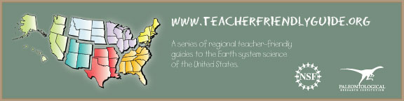

Virtual Fieldwork Experience Development: An Introduction & Brief How-To

Through electronic media, teachers and their students can create virtual representations of field sites that are interesting from an Earth systems science perspective. A Virtual Fieldwork Experience™ (VFE) is an investigation of these field sites, and has the potential to include genuine scientific discovery. Indeed, NASA scientists routinely investigate and interpret sites that they never actually visit.
Our work in developing VFEs and helping others to develop them is part of a larger project: Regional and Local (ReaL) Earth Inquiry. This is a National Science Foundation funded project (DRK-12 0733303) that supports teachers in teaching about local and regional Earth system science using inquiry-based methods.
The driving question for all of the work of the project is: Why does this place look the way it does? The initial place of the question should be local to the school. This project emphasizes the use of the local to understand the global.
The project also features the development of a series of Teacher-Friendly Guides to Regional Earth Science and an extensive teacher professional development program. The Teacher-Friendly Guides to the Geology of the Northeastern and Southeastern US are complete and available for free download at http://teacherfriendlyguide.org/.
Each of the Teacher-Friendly Guides includes a chapter on doing fieldwork. To create virtual fieldwork, the author needs to do actual fieldwork. The chapter outlines things to do before, during, and after visiting a field site; it is complementary to the information presented here.
The below overview is intended to be a living document. Like actual fieldwork, virtual fieldwork and its creation is a bottomless process – we will never fully answer the driving question (in bold, above) absolutely or at every scale. This packet gives you a place start, and we welcome feedback that helps us make this document better.

Why Virtual Fieldwork?
Virtual fieldwork is not necessarily intended to replace actual fieldwork, but to also catalyze and extend it. Creating a series of VFEs from around the country will result in a rich curriculum resource, but that is not the only reason to create them. The act of VFE creation is valuable professional development that creates useful evidence of having done the PD. Through the creation and continued use of virtual fieldwork, a teacher can become a true expert on his or her local environment – perhaps the preeminent expert.
Students can use field sites, whether real or virtual, to study how all the major topics in their Earth science curriculum are manifest in the “real world.” In an ideal situation, the classroom is immediately adjacent to a safe, accessible field site and there is flexibility within the school schedule that allows for in-depth study of the site in ways that cross disciplinary boundaries. Unfortunately, it’s not always practical to visit an actual field site with 30 students repeatedly throughout the year or semester. Through virtual fieldwork, students can come to see how the rock type outside the classroom tells part of the story of that place.
In order to create VFEs, authors must closely study their field sites with an eye toward doing fieldwork with students. VFEs are a stepping-stone to bringing students into the field, even if the field is “only” the schoolyard. VFEs can be used to prepare students for the field and/or process fieldwork after visiting the actual site. In the ideal situation, students will participate in the creation and extension of VFEs, but we recognize that getting to this point may take years.
The ultimate goal of instruction is to build understanding of the Earth system and the ways in which science is used to build that understanding. We bring focus through the use of a small set of bigger ideas and overarching questions.

Overarching Questions:
- How do we know what we know?
- How does what we know inform our decision making?

Earth System Science Bigger Ideas:
- The Earth is a System of Systems.
- The Flow of Energy Drives the Cycling of Matter.
- Life, including human life, influences and is influenced by the environment.
- Physical and chemical principles are unchanging and drive both gradual and rapid changes in the Earth system.
- To Understand (Deep) Time and the Scale of Space, Models and Maps are Necessary.
Virtual Fieldwork should provide the opportunity to explore, describe and build understanding of these questions and ideas.
We also draw attention to the distinction between fieldwork and field trips. We strive to engage learners in figuring things out, while field trips--whether actual or virtual--are too often characterized by trip leaders pointing things out. Building in the opportunity for genuine discovery is challenging but promises to yield longer-term engagement and understanding.
Of course, VFEs also allow some kind of “fieldwork” experience when actual fieldwork is difficult or impossible to carry out. The reasons that actual fieldwork is difficult are fairly obvious:
- Fieldwork is logistically challenging. It’s hard to fit into a typical class period, or even a double lab period. To go off site requires permission slips, bussing and figuring out how to deal with behavior outside the normal classroom setting.
- It costs money. Field trip budgets have been slashed, and weren’t very common at the secondary level before budget cuts.
- Many teachers have only limited experience doing field science themselves. Earth science has more teachers teaching out of field than any other science discipline, and fieldwork is not a component of all Earth science teacher certification programs. It is intimidating to lead fieldwork if you haven’t been through it yourself.
- Fieldwork poses safety and behavior concerns different from those in the classroom. Falling off a cliff has different consequences than falling off a chair.
These issues shouldn’t preclude fieldwork, but they undeniably complicate it. Again, for more information on doing actual fieldwork, see the fieldwork chapter in The Teacher-Friendly Guide.

The PowerPoint VFE Template?
The associated conference session discusses a template intended to simplify VFE production, as this packet is also intended to do. The template is a PowerPoint document with the graphic organizer on the cover of this packet as its centerpiece. Questions in the graphic organizer and in the rest of the template are written generically, so they may be applied to any site. The template is a starting tool useful for creating an “entry level” VFE. It’s available here: http://virtualfieldwork.org/Template.html. This session includes, but goes beyond an introduction to the template.

How are teachers using virtual fieldwork?
VFEs might be used as a single, in-class exercise, or they can be explored across an entire year. We hope that teachers who use and develop VFEs will eventually use them across the entire curriculum, but it makes sense to start smaller. There is no one correct approach to using VFEs in the classroom. Here are some examples of ways teachers are using virtual fieldwork:
- Students in a rural community are using Google Earth to create Powers of Ten tours centered on their homes (based on Eames classic film). This helps students to internalize the abstraction that is central to making maps and to build deeper understandings of scale.
- Students are making geologic maps of the local bedrock.
- Students are making an interpretive guide for a county forest.
- Students are exploring lakes, dams, streams, outcrops, quarries, waterfalls, and more.
For more VFEs, see our growing database at http://virtualfieldwork.org/.

What do I need to consider as I begin to build my VFE?
Considerations fall into four categories:
- Logistical: What do I have the attitude, time, resources, and skills to do? Attitude is listed first as it is the most important factor.
- Pedagogical: How do I bring the scientific content together with technologies in a way that best builds enduring understandings of bigger ideas and overarching questions, as well as the smaller scale ideas and questions I deem important?
- Technological: What hardware and software do I need to assemble the materials for the VFE and to make it accessible to my students? This may include traditional scientific tools, like a rock hammer or a compass, as well as the computer technologies discussed in this session.
- Content: What scientific knowledge, ideas, processes, and practices do I want my students to understand and be able to do at the end of the experience?
Of course, these categories overlap and interplay substantially – teachers of Earth science use Google Earth in different ways than other Google Earth users, for example.
The remainder of this packet is a set of checklists to help you address these categories of considerations for VFE design. Take it with you into the field as you collect pictures and other kinds of data for your VFE; use it to identify issues you think are most important for the development of your VFE. Most of the items in the checklists are there to start your thinking about how to address a particular issue. Content is listed last for the sake of readability. The checklists for the content section are longer than the other categories.

Cross Category Issues:
Many of the questions in the checklist relate to more than one of categories identified above. Because of this overlap, only the cross-category issues and content sections have significant length.

Have I considered this? | Question: | Logistical | Pedagogical | Technical | Content
 | Do I have appropriate safety and first aid equipment and materials? | √ |  | √
 | What content do I want to address? | √ | √ | √ | √
 | Do I have connections in mind to at least a couple of the bigger ideas and overarching questions?  - The Earth is a System of Systems.  - The Flow of Energy Drives the Cycling of Matter.  - Life, including human life, influences and is influenced by the environment.  - Physical and chemical principles are unchanging and drive both gradual and rapid changes in the Earth system.  - To Understand (Deep) Time and the Scale of Space, Models and Maps are Necessary.  - How do we know what we know?  - How does what we know inform our decision-making? |  | √ |  | √
 | How much time do I realistically have to spend on VFE creation? | √
 | How much class time do I want to dedicate to VFEs? | √ | √ | √ | √
 | Am I ok with the trade-off between some expected frustration and the pedagogical payback? | √ | √ | √ | √
 | Can I productively engage students in VFE development? Or is that something to aspire to for next year? | √ | √ | √ | √
 | How does the technology I have serve the goals I wish to meet? | √ |  | √
 | Do I have enough batteries for my powered equipment? | √ |  | √
 | Is the site accessible to me? This includes legal, safety and proximity considerations. | √ | √
 | Are my students familiar with the site? If not, is it accessible to all of my students? If the answer to both questions is no, select another site. | √ | √
 | Are the required pedagogical, technological, and content skills and knowledge needed to create the VFE within my reach for me? Ideally, select challenges that are just within (or just beyond) your reach so that you grow professionally. | √ | √ | √ | √
 | Do I have the hardware (including equipment) and software needed for VFE creation? The bare essentials are a computer, a digital camera, and either PowerPoint of Google Earth. | √ | √ | √

Logistical:
Attitude is intentionally placed first in the list under ‘logistical’ above because it is the most important. We hope that VFE development is used to expand teachers’ skills and knowledge. Performing fieldwork for the first time can be overwhelming, but remember that science is a process, and not even professional geologists capture all that they need in one visit. Over time, you will become more and more comfortable with visiting the field.

Pedagogical:
While most pedagogical questions also address other categories as noted above, there are issues that deserve explicit attention here.
- Does the data you are collecting go toward answering why this place looks the way it does? Or is there a good reason to introduce distracting information?
- If the site is especially striking or unusual, have you considered how to get yourself and your students beyond the “novelty space?” Crudely summarized, the idea of novelty space is the idea that you can’t figure out what’s going on at a field site if you’re either awed by its beauty or freaked out by its perceived dangers. This is one of several reasons for choosing a site that is already familiar to the students.

Technological:
Most technological issues are also logistical; these are addressed in the table above.

Content:
Why does this place look the way it does? The driving question of our work on VFEs can serve as an entry into any major topic in the Earth science curriculum. It also brings relevance to Earth science as we want to start with sites near the school and already somewhat familiar to the students. We want students to look at the familiar with new eyes, and to become skilled at reading their local landscape. Ultimately, we want the skills built by reading the local landscape (being able to tell the story of why a place looks the way it does) to be transferable to any landscape.
What scientific content do you want your students to better understand through their work in the VFE? How does this fit into the larger goals of the course? Can you draw, and help your students to draw, connections to bigger ideas and overarching questions? What topics in Earth science can be addressed by doing fieldwork?
Below are questions taken from the graphic organizer that serves as the cover of this packet. Your VFE likely won’t address all of them, but you should be strategic about what you minimally wish to address.

For all of the following questions:
- How do you know? (What evidence is there?)
- What does it tell you about past environments?
- What does it imply about the future?

- Describe the shape of the land.
- Are there mountains, valleys, or hills?
- What are the valley shapes?
- What can form valleys?
- What can cause mountains or hills to form?
- Are the mountains or hills young or old?
- What role do tectonics play in shaping the site?

- What effects has water had on the landscape?
- Is water depositing material, eroding material, or both?
- Is the action of water primarily chemical, primarily physical, or both chemical and physical?

- What effect has the climate had on the landscape?
- Was the past climate different?
- What factors may have been affected or caused by climate?

- What does the arrangement of the rocks indicate about past conditions?
- Do the rocks seem to form a sequence?
- Where would you find the oldest rocks?
- Youngest rocks?
- Are there different kinds of rocks at different outcrops?

- What types of rock are there and what do they indicate about past conditions?
Sediments & Sedimentary Rocks
- Is it clastic or organic/chemical?
- If clastic, what is the grain size?
- If organic, what minerals is it made out of?
- Are there fossils?
Metamorphic
- Is it foliated or non-foliated?
- What was the parent rock?
Igneous
- Did the rock form above or below ground?
- Is it felsic or mafic?

- What effects has life, including human life, had on the landscape?
- How have plants shaped the landscape?
- How have animals generally, and humans in particular, changed the landscape?
- On what scale?

Closing thoughts
This document is almost all about getting you started in the creation of VFEs. How do you know when to stop? It may be more productive to think of VFEs becoming ready for use rather than finished. Here's a nice quote from Wendell Berry's essay Faustian Economics that relates:

It is the artists, not the scientists, who have dealt unremittingly with the problem of limits. A painting, however large, must finally be bounded by a frame or a wall. A composer or playwright must reckon, at a minimum, with the capacity of an audience to sit still and pay attention. A story, once begun, must end somewhere within the limits of the writer’s and the reader’s memory. And of course the arts characteristically impose limits that are artificial: the five acts of a play, or the fourteen lines of a sonnet. Within these limits artists achieve elaborations of pattern, of sustaining relationships of parts with one another and with the whole, that may be astonishingly complex. And probably most of us can name a painting, a piece of music, a poem or play or story that still grows in meaning and remains fresh after many years of familiarity.

We believe that, upon close investigation, any field site can be seen as interesting from an Earth system science perspective.
These are issues of Technological, Pedagogical and Content Knowledge, or TPACK for short. See http://tpack.org/ for more information.
For more about novelty space, see, for example: Orion, N., and Hofstein, A. (1994). Factors that influence learning during a scientific field trip in a natural environment. Journal of Research in Science Teaching 31: 1097–1119.

